# CSS3 layout

1. Use the absolute CSS positioning property to create the following output in the provided HTML file.

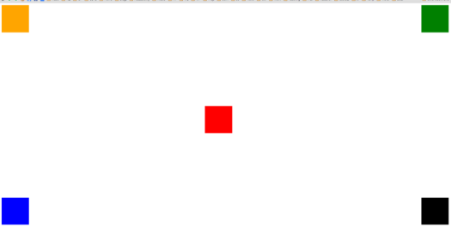

1. Without touching the provided HTML and using only absolute positioning, re-create the following output:



1. Re-create the following output. Hint: use transparency, not z-index.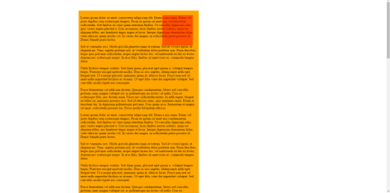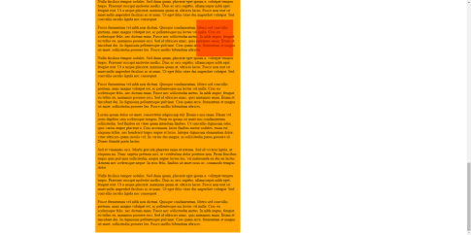
2. Create the following 1st letter effect using CSS

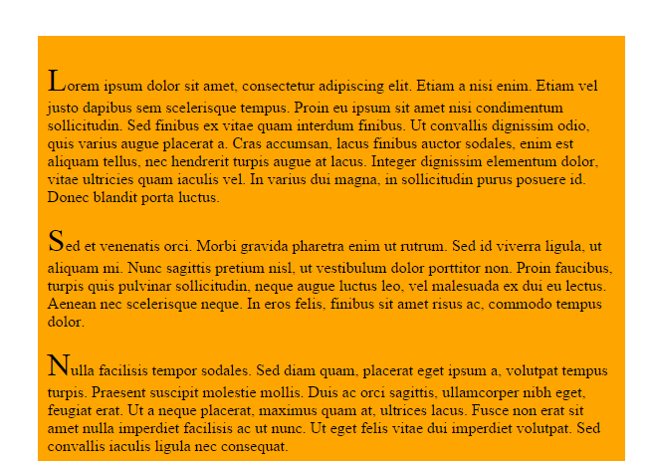

1. Use the relative CSS positioning property to create the following output in the provided HTML file.

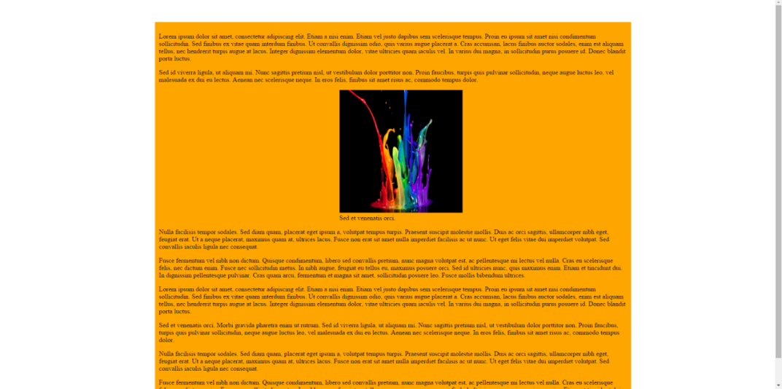

1. Create the following output using the CSS floating property

